Impact of Cultural Values on Consumer Behavior
Student’s Name
Institutional Affiliations

Impact of Cultural Values on Consumer Behavior
Green Marketing
To begin with, green marketing is defined as a process of selling products as well as services grounded on their environmental benefits. In the modern world, firms committed to corporate social responsibility and sustainable development practice green marketing. Notably, various companies are making a considerable effort to enforce sustainable business practices, as they understand that doing so help them make their products as well as services attractive to consumers and mitigate expenses (Ward, 2018). On the same note, contemporary organizations have realized that demonstrating a substantial degree of social responsibility heightens brand loyalty among socially conscious clients. With that said, this paper addresses the existing interrelationship between green marketing and consumer behavior. On the same note, the paper uses three specific examples of organizations marketing to depict the value of green marketing.
Interrelationship Between Consumer Behavior and Green Marketing
It is important to note that concern about the environment is a significant public issue. Specifically, this has made a positive change in consumer behavior towards environmentally related products. Nowadays, customers are sensitive to organizations and products that do not consider eco-friendly production processes. Therefore, both companies and consumers must have a responsibility towards existing environmental issues. Notably, individuals purchase and support firms that practice green marketing. It is clear that green marketing has a considerable effect on consumer behaviors, especially their purchasing patterns (Jansson, Marell, & Nordlund, 2010). It is noteworthy that green marketing activities play a critical part in switching consumer-purchasing behavior to buy eco-friendly products. In simple terms, organizations practicing green marketing experience more sales and attract a considerable amount of clients to purchase their products and services
Examples of Organizations using Green Marketing
In the modern world, a number of organizations have embraced the idea of green marketing. These firms understand that green marketing activities attract many clients to their products and have positive consumer purchasing patterns. On the same note, companies recognize that going green is good for the environment. Nowadays, customers are aware of their effect on the environment and this makes green marketing an important aspect in the business world. Many clients are sensitive to eco-friendly, sustainable, recyclable, as well as organic products. Therefore, companies, such as Coca Cola, IKEA, and Timberland have embarked on green marketing campaigns to achieve sustainable and eco-friendly products and services.
Coca Cola Company
Coca Cola Company has a campaign tagged to Live Positive to make considerable transformations throughout the globe via sustainability. The firm's main objective in this campaign is to empower female entrepreneurs, help conserve water across the world, as well as encourage a healthful lifestyle with adequate choices and exercise. Notably, this green marketing campaign helps the organization to attract a number of consumers to its products (Ken, 2018). Additionally, this initiative is committed to make a positive difference to the world far as sustainability is concerned. It is important to note that part of this campaign is to introduce its plant bottle packaging that utilizes materials recycled from plants to conserve resources and reduce the firm’s footprint. In my opinion, the Coca Cola Company uses green marketing to improve environmental sustainability. Furthermore, it is evident that the company is concerned with the well-being of its consumers, the reason it is introducing a plant bottle.
This is a screenshot of the Coca Cola Company's campaign
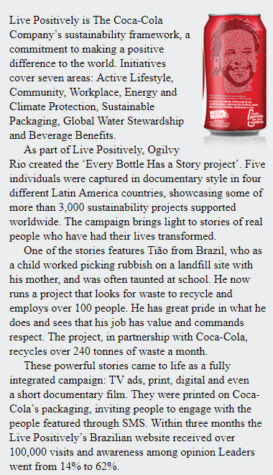
IKEA
IKEA is a Swedish furniture brand that has come up with its sustainability approach known as People and Planet Positive. In this campaign, the firm believes that clients should not make a choice between affordable prices, sustainability, and stylish designs when buying their goods and services. The organization utilizes online content to promote as well as encourage clients to live an eco-friendly conscious lifestyle. In particular, the enterprise leads by example with eco-friendly practices that consist of embracing 90% of its building as well as mitigating waste delivered to landfills. It is noteworthy that the organization has won many marketing rewards with its green efforts. In my opinion, the company at hand has embraced green marketing to enhance eco-friendly practices as well as improved environmental sustainability. Furthermore, the practice has attracted many customers to purchase IKEA products, which in turn increases the company's profits.
This is a screenshot of IKEA’s campaign
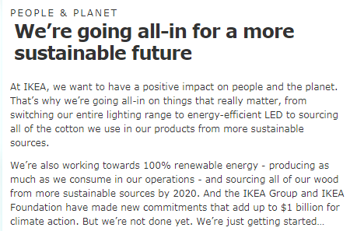
Timberland
Timberland Company is a clothing organization that is known for its hiking boots as well as outdoor wear. The organization came up with Earthkeepers campaign to promote as well as support green marketing. The campaign supports eco-friendly practices as well as attempts to motivate people to environmental behavior change. In this case, the firm features a collection of items with recycled materials. In addition, the campaign encourages the firm’s customers to be accountable for their actions in the outdoor (Ken, 2018). For instance, the organization utilized television advertisements as well as print pieces not forgetting social media and attractive interactive microsite to promote this campaign. In my opinion, the company at hand did a commendable job to ensure a sustainable environment.
The screenshot below shows Timberland’s Marketing Campaign.
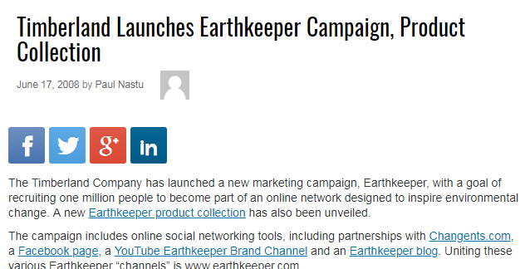
Overall, it is evident from the discussion above that many organizations are embracing green marketing to support environmental sustainability. On the same note, firms, such as Coca Cola, IKEA and Timberland understand that customers are eco-friendly sensitive; therefore, winning their trust need a comprehensive green marketing initiative. In fact, green marketing has a substantial influence on consumer purchasing patterns. Moreover, many firms have realized that demonstrating a high level of social responsibility increases brand loyalty among conscious customers. In simple terms, green marketing plays a critical role in ensuring environmental sustainability as well as impacting consumer behavior.

References
Jansson, J., Marell, A., & Nordlund, A. (2010). Green consumer behavior: determinants of curtailment and eco-innovation adoption. Journal of consumer marketing, 27(4), 358-370.
Ken, C. (2018). Brands doing green marketing right. Content Marketing. Retrieved from https://contentwriters.com/blog/brands-doing-green-marketing-right/
Ward, S. (2018). Green marketing definition. The Balance Career. Retrieved from https://www.thebalancesmb.com/green-marketing-2948347

